
Lab Report 06
Faculty of Computing

CS117: Applications of ICT CS-16
Lab 06: Networking Fundamentals, Connectivity
Instructor: Ms. Kashaf Raheem
Lab Engineer: Ms. Syeda Fatima Sajid
Name: Hafiz Muhammad Umais Amjad
Reg No: 588616
Department: BSCS-16 (2026)
Section: D

Task 1:
Run:
hostname

Record your hostname. Then run:

ipconfig /all
Find the active network interface. Record:
Item | Your Value
Hostname
Adapter/interface
IPv4 address
Subnet mask
Default gateway
DNS server
MAC/physical address

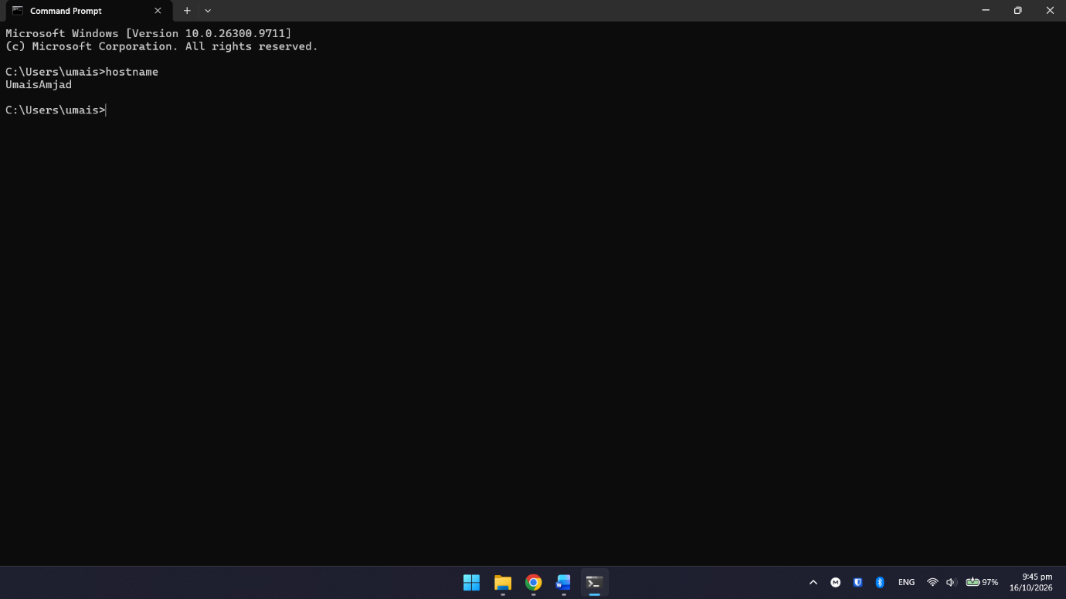
Output Screenshot:

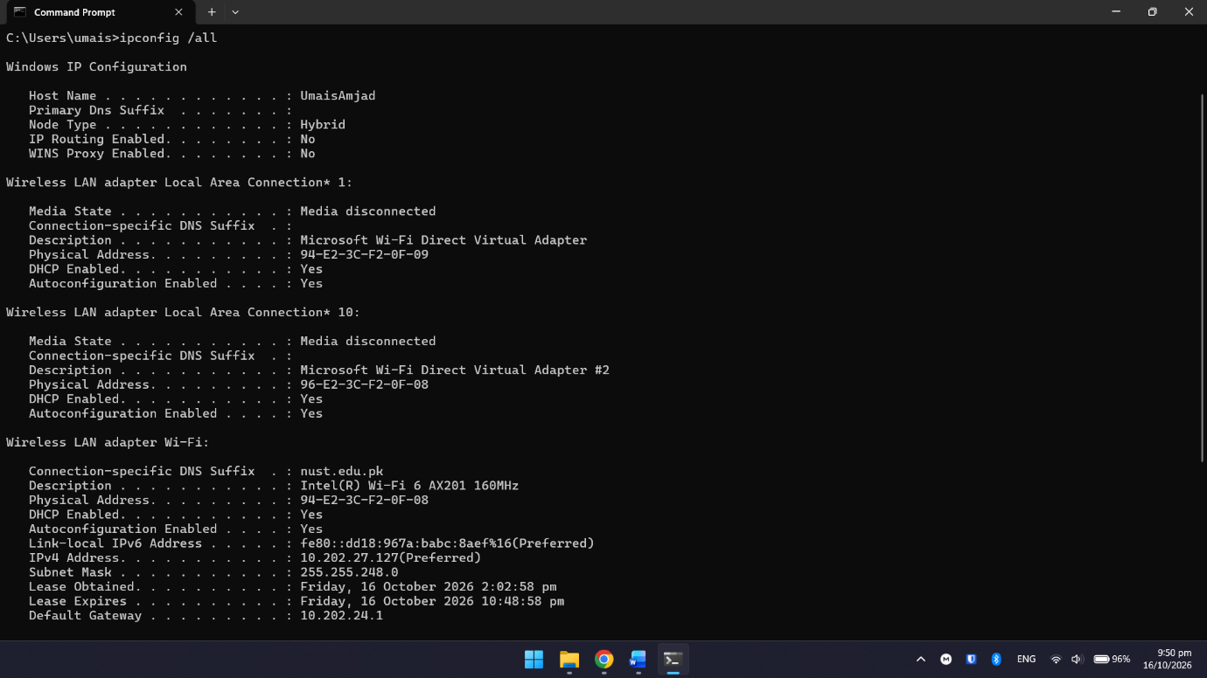

Think
Which value tells you:

Your logical address on the IP network?
IP address such as IPV4 or IPV6 address tells us about the logical address of device on network.

The address of your network interface?
MAC Address refers to the unique identifier of the hardware / Network interface card over a network that uniquely identifies each device. It remains constant.

Where traffic normally goes when the destination is outside your local network?
Default Gateway or Gateway address. When destination is outside the local network the traffic goes through this address.

Task 2:

Test 1 — Loopback
Windows:
ping 127.0.0.1

Ubuntu:
ping -c 4 127.0.0.1

Prediction:
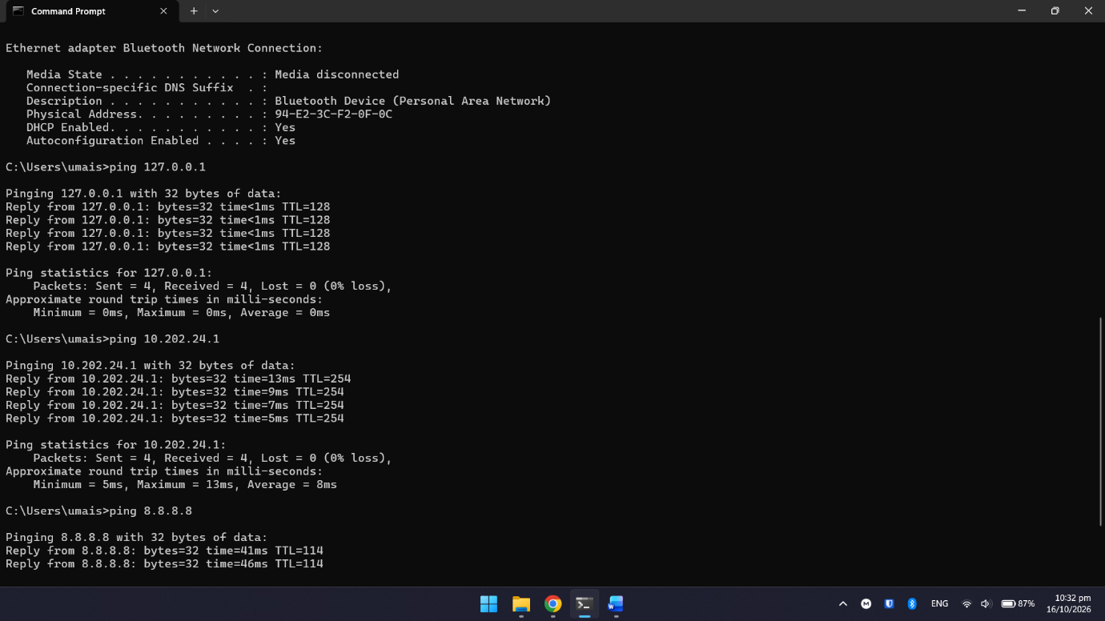

Task 3:

DNS Lookup
Run:
nslookup example.com

DNS server:
ISBPVAD01.nust.edu.pk

Returned IP address:
10.250.64.73

Think
Suppose:
- a remote IP is reachable,
- but its hostname cannot be resolved.
Which service might you investigate?

I will check the Domain Name Service (DNS) because if IP is reachable then DNS Service is causing issue as hostname cannot be resolved.

Trace a Route
Windows:
tracert example.com

First hop:
1 12 ms 3 ms 10 ms 10.202.24.1

Number of visible hops:
13

Did any hops show a timeout?
Yes
A timeout on one hop does not automatically prove that the entire route is broken.
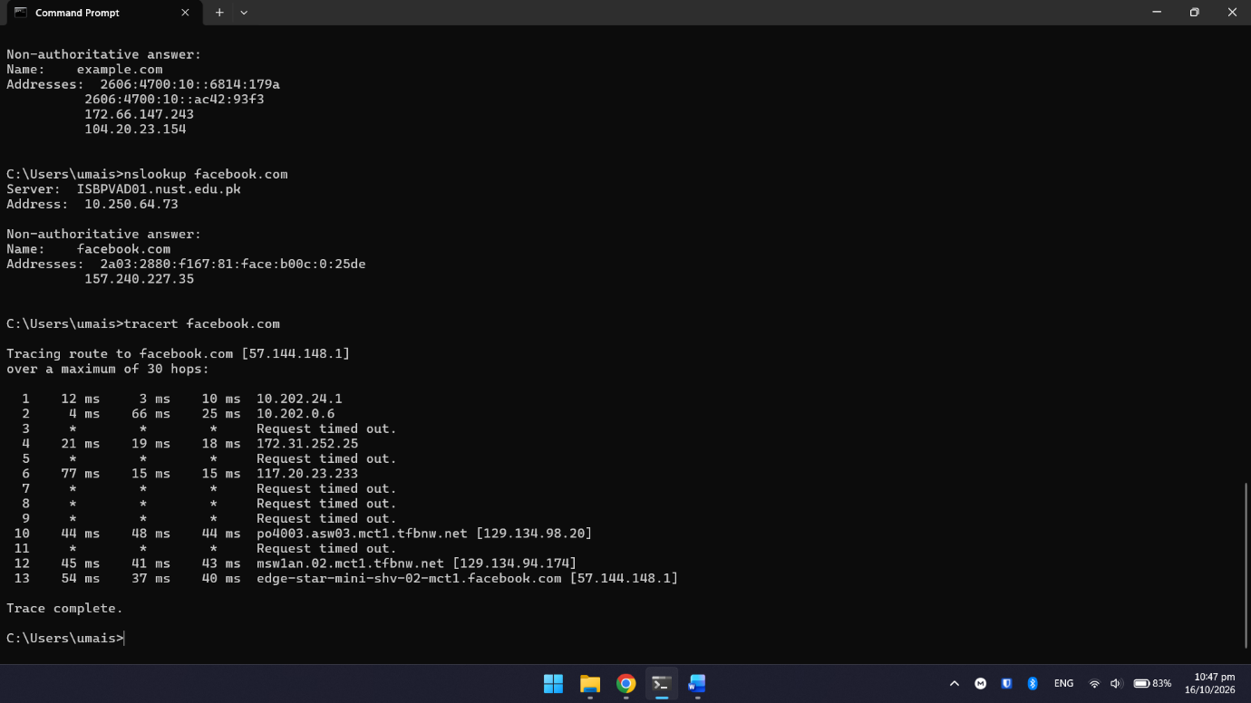

Task 4:

Simple 24 Networks:
For this lab, focus on simple 24 networks

Practice
Are these pairs on the same network?

Pair A
192.168.5.10
192.168.5.90

Answer:
- Yes

Pair B
192.168.5.10
192.168.6.10

Answer:
- No

Pair C
10.20.30.5
10.20.30.200

Answer:
- Yes

Task 5:
Use Wireshark only as directed by your instructor. Capture only your own lab-generated traffic.
Steps
- Open Wireshark.
- Select the instructed network interface.
- Start capture.
- Generate a short ping to your local gateway.
- Stop capture.
- Apply this display filter:

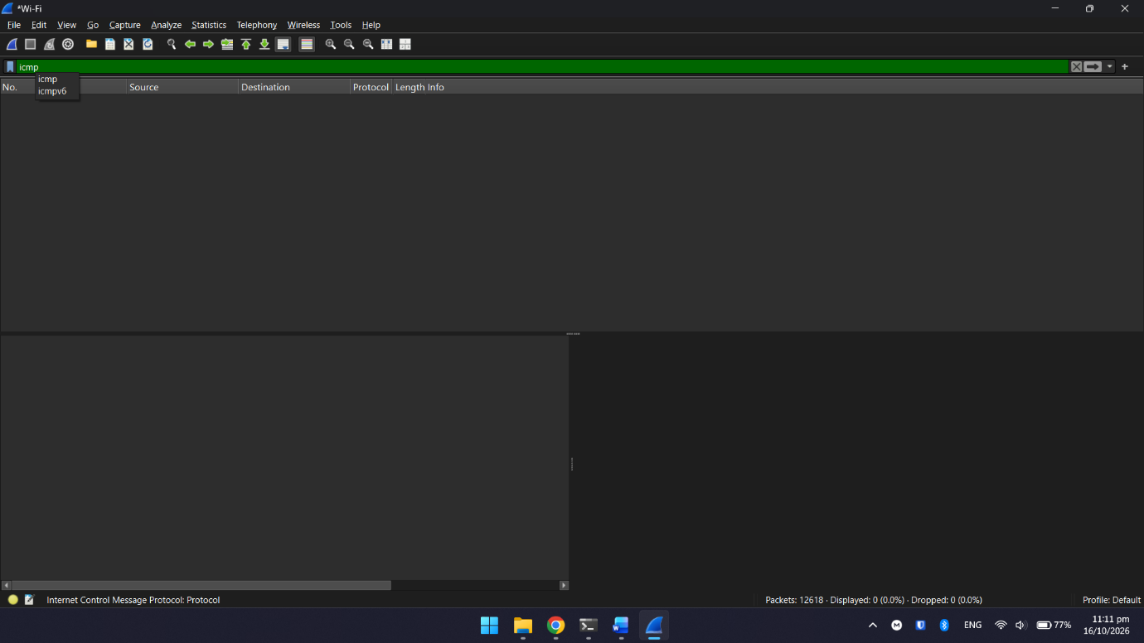
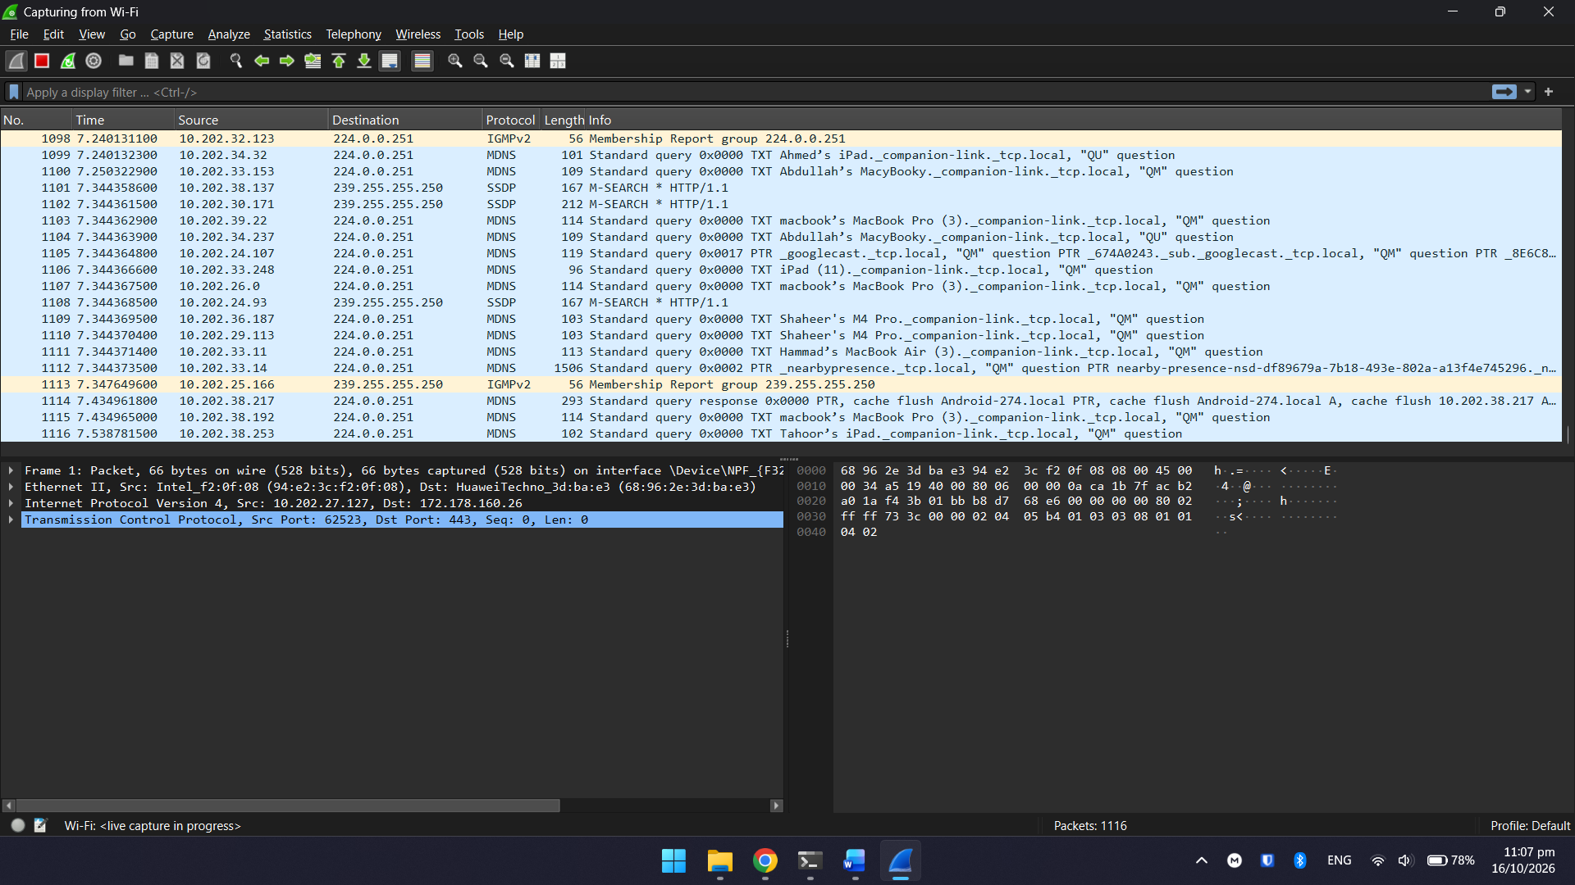

Record:
Item Echo Request Echo Reply
Source IP - -
Destination IP - -

Compare the Three Tools:

Ping
Shows whether replies were received.

Packet Tracer
Shows a simulated packet moving through network devices.

Wireshark
Shows details of actual packets seen on the selected interface.

